**The Lending System**

**Functions**

**Multiply**



* Simply multiplication function

**Calculate Components**

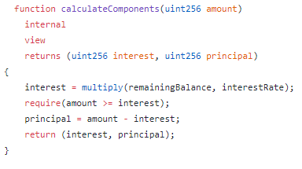

* Calculates the interest and principal that the borrower has to pay/paid

**Calculate Collateral**

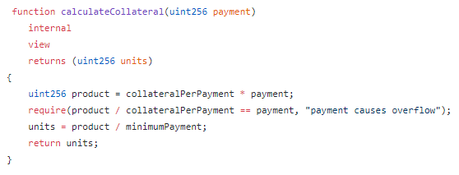

* Calculates the collateral based on the DID’s of the borrower and the initial amount handed out

**Process Period**

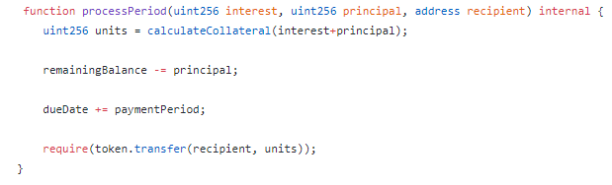

* Used to calculate the remaining time left on the loan

**Make Payment**

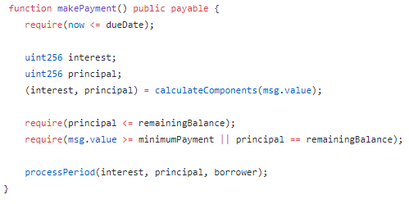

* Function for the user to make payments on their loan
* Calculates changes in interest and principal based on the payment

**Missed Payment**

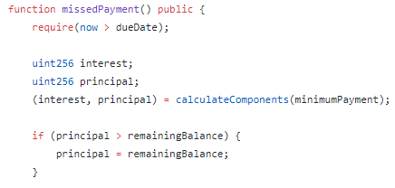

* If the user missed a payment this function will calculate the changes in interest and principle
* Will also make sure that the user does not receive the collateral that they would have received

**Return Collateral**

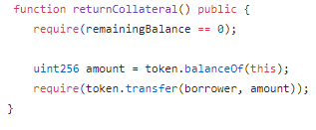

* Sends some collateral back to the user if they make the payment on time